A PERSUASIVE READING FOR YEARS 5–6
Let Every Reader
Find Their Voice
Why our school should trial a Storytime Dog program
A persuasive proposal to the School Council • 386 words
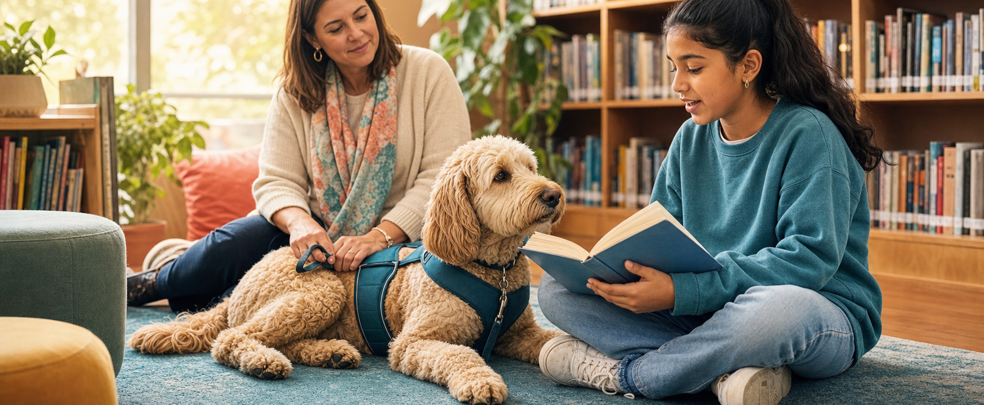
A calm listener can make a brave reader.
A dog cannot correct a tricky word — but it can help a nervous reader find the courage to try it.
Picture the library after lunch. A student opens a book, takes a breath and begins to read. Beside them, a trained dog waits — no frown, no interruption, no judgement. Our school should run a one-term Storytime Dog trial because it could strengthen reading confidence, support wellbeing and help more students feel that the library belongs to them.
THE CASE FOR A ONE-TERM TRIAL

Confidence grows through practice
First, reading improves when students are willing to practise. For a hesitant reader, reading aloud can feel like walking onto a stage without rehearsing. A calm dog changes the audience. In a 2022 study of 24 young readers who needed extra support, researchers found evidence of improved reading performance, particularly after children read to a dog.[1] The study was small, so it does not prove that every child will improve; however, it gives our school a sensible reason to test the idea carefully. A weekly session could turn “I can’t” into “I’ll try.”

EVIDENCE, EMPATHY AND A FAIR RESPONSE

Calm minds are ready to learn
Just as importantly, a Storytime Dog could make reading feel safer. A systematic review found promising links between reading to dogs and greater motivation and confidence, as well as reduced anxiety, although the researchers warned that the overall evidence was still limited.[2] That honest caution matters. We should not promise a miracle. We should offer a welcoming, well-supervised space where students can practise, connect and succeed one page at a time.
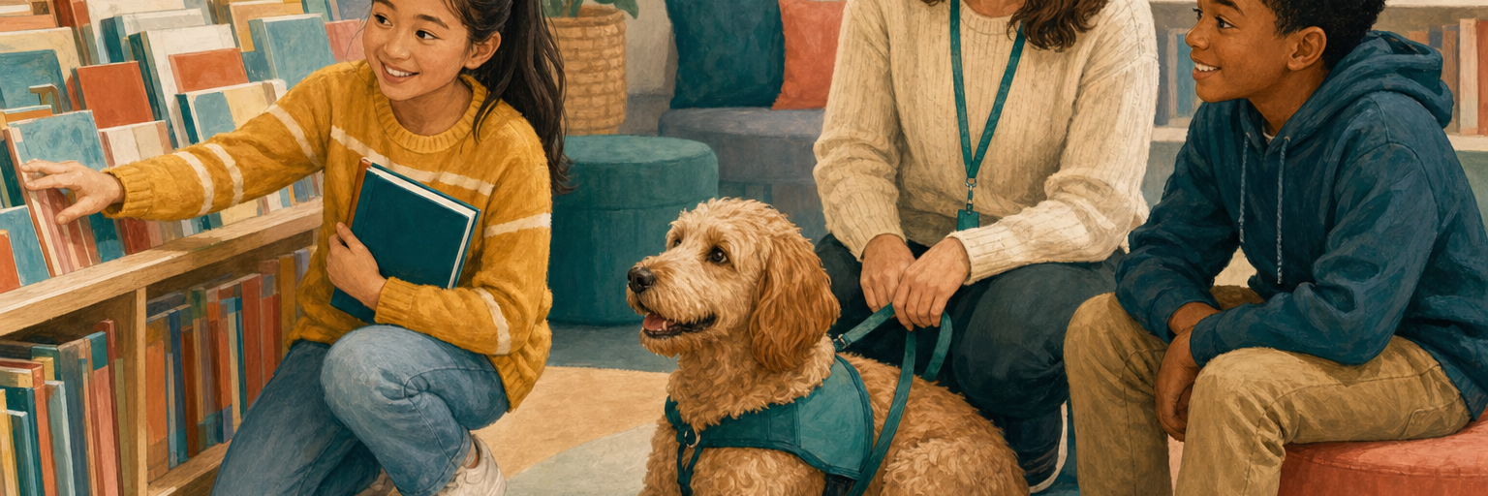
The goal is not a novelty. It is a safe routine that invites students into reading.

Safety must come first
Of course, some families may worry about allergies, fear or distraction. These concerns are valid — and they are exactly why the program must be planned, not improvised. NSW Department of Education guidance recommends notifying families, identifying allergies or fears, providing handwashing, using a handler and completing a risk assessment.[3] Students who do not wish to participate must have an equally supportive reading option. With clear boundaries, a rest space for the dog and short scheduled sessions, safety and inclusion can guide every decision.

Start small. Measure carefully. Decide together.
Therefore, the School Council should approve a one-term trial for a small group of volunteer readers. Teachers could track attendance, reading confidence and student feedback before reviewing the results with families. A Storytime Dog will not replace skilled teaching, patient adults or daily practice. It could, however, open the door for students who are still waiting to see themselves as readers. Let us give them a calm listener, a fair chance and one more reason to turn the page.
THE PROPOSAL Approve a one-term, opt-in Storytime Dog trial with a trained handler, a documented risk assessment and a review of student outcomes.

Evidence used in this exemplar
[1] Supporting Young Readers — A 2022 mixed-methods study of 24 children aged 7–8.
[2] Children Reading to Dogs — A 2016 systematic review that found promising but low-quality evidence.
[3] Support Dog Guidelines — NSW Department of Education guidance on risk, hygiene, allergies, supervision and animal welfare.
Model-text note: This is an original classroom exemplar. The argument uses qualified claims so students can see that trustworthy persuasion is strong, specific and honest about the evidence.

